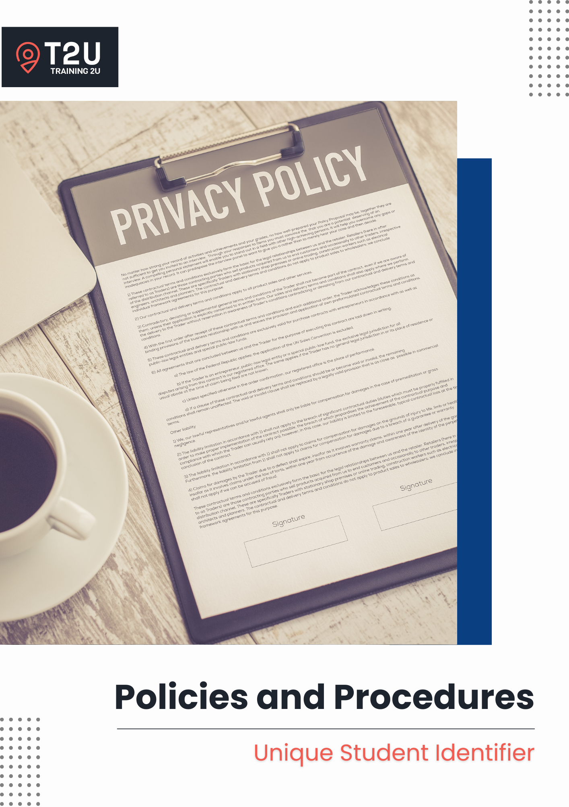

Table of Contents

Unique Student Identifier 3

Purpose 3

Scope 3

Software 3

Responsibilities 3

General Principles 3

Compliance 4

Continuous Improvement 5

Related Documents 5

USI Verification Procedure 6

USI Verification Process Flow-Chart 7

# Unique Student Identifier

## Purpose

The Unique Student Identifier (USI) was introduced under the Student Identifiers Act 2014 to provide learners with a comprehensive training record from a single source. All students undertaking nationally recognised training must have a valid USI for qualification issuance, effective from 1 January 2025. This policy ensures compliance with the revised Standards for RTOs 2025 and the Student Identifiers (VET Exemptions) Instrument 2021 while maintaining secure and efficient USI management processes.

## Scope

This policy applies to:

* All learners and Administrative & Support Staff; and
* All systems and processes relating to enrolment, USI verification and issuance of training outcomes.

## Software

* Ecosystem: AIMS Institute of Training and Technology

## Responsibilities

**CEO**

* Ensures compliance with USI requirements and legislation.
* Oversees secure data management.

**Administrative & Support Staff**

* Collects, verifies, and maintains USI records.
* Manages communications with students regarding USI verification errors or exemptions.

## General Principles

As an RTO, Training 2U is committed to:

* Ensuring students undertaking nationally recognised training provide a valid USI. Should a student not have one, they are required to obtain one from the Australian Government’s USI website [here](https://www.usi.gov.au/your-usi/create-usi).
* Verifying each student’s USI to confirm their validity prior to issuing any Qualification or Statement of Attainment documents. At Training 2U, we verify the validity of a student’s USI during the enrolment stage, or when the USI is provided if it is not provided during the enrolment stage.
* Following exemption guidelines as outlined in the Student Identifiers (VET Exemptions) Instrument 2021 where a USI is not required to be collected, such as:
  + Where, after having consulted with ASQA, is exempted from the requirement to collect and submit AVETMISS compliant data on a nationally recognised training activity where submission of that data would conflict with defence or national security legislation or could jeopardise the security or safety of defence, border protection, customs, national security or police personnel;
  + International students undertaking and completing their nationally recognised training program outside of Australia; and
  + Individuals who have been granted an exemption from the Registrar to be assigned a USI in order to be issued a VET Qualification or Statement of Attainment where the individual has a genuine personal objection to being assigned a USI.
* Where a USI **is not required** to be collected as per the Student Identifiers (VET Exemptions) Instrument 2021, Training 2U has a responsibility to inform these students that their assessment results will not appear on their authenticated VET transcript or be available to them through the USI registry system – this information is relayed to the student pre-enrolment in the Student Handbook.

## Compliance

This policy aligns with:

* **Standards for RTOs 2025**:
  + **Standard 2.1** – VET students have access to clear and accurate information, including to make informed decisions about the training product and the RTO, and are made aware of changes that affect them.
  + **Standard 4.2** – Roles and responsibilities are clearly defined and understood.
  + **Standard 4.3** – Risks to VET students, staff and the RTO are identified and managed.
  + **Standard 4.4** – The RTO undertakes systematic monitoring and evaluation to support the delivery of quality services and continuous improvement.
  + **Compliance Requirements –** **Student identifiers.**
* **Student Identifiers (VET Exemptions) Instrument 2021**

Failure to comply with this policy can have serious consequences, including but not limited to:

* **For the RTO** – breaches of legislation or regulatory requirements may result in financial penalties, loss of registration, reputation damage, or regulatory enforcement actions.
* **For Staff Members** – staff found to have knowingly or negligently failed to comply with this policy and any associated legislative or regulatory requirements may face disciplinary actions, up to and including termination of employment.
* **For Learners and Clients** – non-provision or invalid USI may prevent qualification issuance or the inclusion of training records on VET transcripts.

## Continuous Improvement

* Feedback from staff, learners, clients and industry stakeholders will be used to inform improvements to compliance processes and the effectiveness of our operations.
* An internal audit is to be conducted at least once per year to assess our compliance with this policy and the relevant legislative and regulatory requirements. The audit schedule is outlined in our *Continuous Improvement Schedule* and areas for improvements are documented in our *Continuous Improvement Register*.
* Internal audit review questions for self-assurance purposes should include:
  + Are the USIs being collected unless there were exemptions?
  + Are the USIs being properly validated?

## Related Documents

* Continuous Improvement Register
* Continuous Improvement Schedule
* Enrolment Form
* Enrolment Interview Form
* Student Handbook

## USI Verification Procedure

1. **Collection**
2. A student’s USI is collected during the enrolment process, in their enrolment form.
3. If a student is having trouble creating a USI, refer them to the USI Help Centre.
4. **Verification**
5. When a student’s *Enrolment Form* is received, the Administrative & Support Staff is to confirm that a USI has been provided.
6. If no USI is found, it is to be requested for during the Enrolment Interview and noted in the *Enrolment Interview Form*.
7. If a USI has been provided, the Administrative & Support Staff is to verify that the information matches to that on the USI Registry. The learner’s USI is to be verified on the Australian Government’s USI platform: [www.usi.gov.au](http://www.usi.gov.au)and once verified, the notes are to be entered into the student’s file. OR Student Management System.
8. **Record management**
9. If the USI is verified to be correct, a note is to be left so that you know that is has been verified to be correct.
10. If an error returns advising that the information entered is not matching, it is advisable to check the information and try again a second time. Sometimes, the student may have entered their first name as Kate, however their first legal name is Katherine. The first name provided by the student must align with their first legal name as that would have been the name provided when they registered for their USI.
11. If it is still returning an error, the Administrative & Support Staff is to note it in the *Enrolment Interview Form* prior to the Enrolment Interview, inform the student of the error during the Enrolment Interview and request for them to provide us with the correct information.
12. All information relating to a student’s USI must be kept secure. This includes the information stored within the Student Management System and only authorised personnel will have access to this information.

## USI Verification Process Flow-Chart

Commence USI verification process

Verify USI information on the USI portal

Collect student’s USI (unless exempted)

Contact the student to advise them of the error and request for the student to send through or confirm the correct information

Is the USI verified?

N

Y

A note is to be left when the USI has been verified

**Version Control**

|  |  |
| --- | --- |
| **Title** | **Policies and Procedures – Privacy Protection** |

|  |  |
| --- | --- |
| Date of Approval | 1 July 2025 |
| Next Review Date | 1 July 2026 |
| Responsible Authority | CEO – Tooba Khan |
| Version Number | 2.0 |
| File Location | organisation’s server |

**Details of Changes**

|  |  |  |
| --- | --- | --- |
| **Version No.** | **Date** | **Amendments** |
| Version 1.0 | 01/02/2022 | - |
| Version 1.1 | 15/01/2024 | Fixed minor grammatic errors |
| Version 2.0 | 01/07/2025 | Updated in line 2025 Standards for RTOs |

*Add more rows as required.*