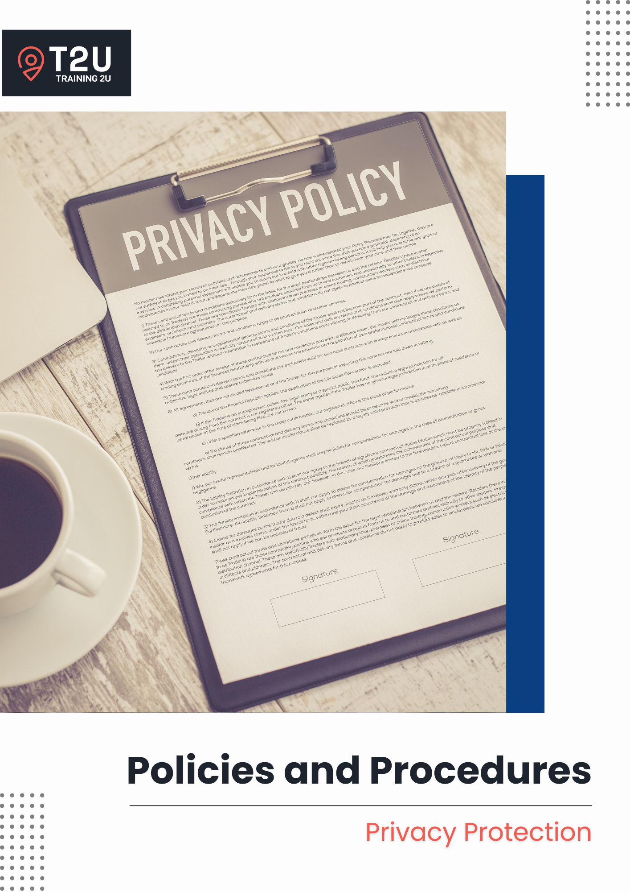

Table of Contents

Privacy Protection 3

Purpose 3

Scope 3

Software 3

Responsibilities 3

Definition of Personal and Sensitive Information 4

General Principles 4

Privacy Notice 5

Data Collection Methods 5

Access, disclosure, and correction of personal information 6

Management of personal information 7

Direct Marketing 8

Google Analytics and Cookies 8

Compliance 9

Continuous Improvement 9

Related Documents 10

# Privacy Protection

## Purpose

As a Registered Training Organisation, Training 2U has a responsibility to collect, use and store personal and sensitive information on our students, clients and staff members. This policy outlines our principles and guidelines to meet our legislative obligations.

## Scope

This policy applies to:

* All staff, learners, and clients; and
* All personal and sensitive information collected, used or stored by us.

## Software

* Ecosystem: Training 2U

## Responsibilities

**CEO**

* Ensures compliance with privacy laws and data protection policies.
* Oversees the implementation of secure data management practices.
* Approves privacy notices.

**Administrative & Support Staff**

* Manages the collection, storage, and secure handling of personal information.
* Responds to and facilitate requests for access, correction or complaints regarding personal information.

**All Staff**

* Complies with data protection protocols.
* Reports any suspected data breaches immediately.

## Definition of Personal and Sensitive Information

Under the Privacy Act 1988 and the Privacy Amendment (Enhancing Privacy Protection) Act 2012 (s6(1)), personal and sensitive information is defined as follows:

* Personal information – information or an opinion about an identified individual, or an individual who is reasonably identifiable: (a) whether the information or opinion is true or not; and (b) whether the information or opinion is recorded in a material form or not.
* Sensitive information – information or opinion about an individual’s:

1. racial or ethnic origin, or nationality
2. indigenous status
3. languages spoken
4. political opinions or membership of a political association
5. religious beliefs, affiliations, or philosophical beliefs
6. membership of a professional or trade association, or a trade union
7. sexual preferences or practices
8. criminal record
9. health such as one’s disability or long-term impairment status, and dietary requirements
10. genetics (that is not otherwise health information)
11. biometric (used for the purposes of automated biometric verification or biometric identification)
12. biometric templates

## General Principles

At Training 2U, we are committed to:

* Collecting, using, and storing personal and sensitive information in compliance with legislative and regulatory requirements, including the Privacy Act 1988 and the National Vocational Education and Training Regulator (Data Provision Requirements) Instrument 2020.
* Collecting personal and sensitive information in accordance with the Australian Vocational Education and Training Management Standard (AVETMISS).
* Ensuring transparency by notifying individuals of data collection purposes at the point of enrolment or as soon as practicable.
* Protecting personal and sensitive information from misuse, interference, and unauthorised access through secure systems and processes.
* Retaining personal information for a period of **30-years**, as required by law, and securely disposing of data when it is no longer necessary for business purposes.

## Privacy Notice

Clause 7.2 of Part B in the National Vocational Education and Training Regulator (Data Provision Requirements) Instrument 2020 specifies that Registered Training Organisations (RTOs) must inform students about the purposes for which their personal information is collected, used, or disclosed. This includes making students aware of the Privacy Notice outlined in Schedule 1 of the National VET Data Policy. Training 2U provides a Privacy Notice on our website and in our Student Handbook. Training 2U also provides a privacy notice at the start of the Enrolment Form so that students and clients are aware of the collection of their personal and sensitive information at the point of enrolment.

In our Privacy Notice, we outline the following information:

* Why we collect personal information;
* How we use the personal information collected;
* Who we are legally obliged to disclose the personal information collected to;
* How we disclose the personal information collected;
* How NCVER and other bodies handle the personal information collected;
* Surveys that students may receive from a government department of an NCVER employee, agent, third-party contractor or another authorised agency; and
* Who can be contacted to request access to the personal information we have collected, how to correct the personal information we retain, how to make a complaint about how the personal information collected has been handled, and to ask questions about the Privacy Notice.

## Data Collection Methods

Training 2U endeavours to notify individuals of the collection of their personal and sensitive information before, or at the time of collection, or as quickly as possible thereafter, such as at enrolment. Notifications are usually made in writing but may be verbal.

Training 2U uses the following avenues to collect information:

* Student and client personal and sensitive information is collected directly from our students and clients using administrative tools such as enrolment forms, enrolment interview forms, recognition of prior learning application forms, credit transfer forms, complaint forms, appeal forms, payment refund forms, surveys and questionnaires. This information is entered into the Student Management System and the physical forms or documents are scanned into the learner’s folder and stored electronically with any hard copies destroyed responsibly.
* Student and client personal information such as personal contact information may also be collected at the enquiry stage directly from individuals.
* Training 2U also collects information relating to our performance as an RTO and this information can be collected electronically or in hard copy formats. The responses are then collated, reviewed and analysed (where required), and any hard copies are then destroyed (if applicable).
* Staff personal and sensitive information is collected from individuals when they come in for an interview and upon commencement of their employment or contractual period with Training 2U.

If Training 2U should receive any unsolicited personal or sensitive information, it will be treated and managed according to the Australian Privacy Principles.

## Access, disclosure, and correction of personal information

Learners and third-party individuals or organisations may request access to the personal and sensitive information held by Training 2U where the information has been collected directly from individuals, subject to certain exceptions prescribed by the Australian Privacy Principles. Request for access to the personal and sensitive information should be made in writing. You can refer to our Record Keeping and Access policy for more information on accessing personal information.

Training 2U does not sell or share your personal and sensitive information to third-parties for marketing purposes. We do not disclose any personal and sensitive information other than for the purpose which it was collected for, if an individual has consented to a secondary purpose or would reasonably expect, or if required to by law.

We are obligated to collect and disclose personal information to the National Centre for Vocational Education Research (NCVER), the Australian Skills Quality Authority, as well as any relevant State or Territory Training or Funding Authority in accordance with any legal or contractual obligations such as funding contracts and reporting obligations. Training 2U will inform and seek consent from the individuals concerned at the point of enrolment.

Under the National Vocational Education and Training Regulator (Data Provision Requirements) Instrument 2020, we are required to collect personal information about you and disclose that personal information to the National Centre for Vocational Education Research (NCVER). NCVER is responsible for collecting, managing, analysing and communicating research and statistics about the Australian VET sector. NCVER collects, holds, uses and discloses your personal information in accordance with the law, including the Privacy Act 1988 and the NVETR Act 2011. This information may be used and disclosed by NCVER to the Australian Government department of Employment and Workplace Relations (DEWR), Commonwealth authorities, State and Territory authorities (other than Registered Training Organisations) that deal with matters relating to VET and VET regulators for the purposes of those bodies, including to enable:

* Populating authenticated VET transcripts;
* Administering vocational education training, including program administration, regulation, monitoring and evaluation;
* Facilitation of statistics and research relating to education, including surveys and data linkage; and
* Understanding the VET market, such as how the VET industry operates, for policy development purposes, workforce planning and consumer data.

NCVER may also disclose personal information to persons engaged by NCVER to conduct research on NCVER’s behalf and NCVER does not intend to disclose any personal information to any overseas recipients. You can refer to NCVER’s Privacy policy [here](http://www.ncver.edu.au/privacy) for more information on how NCVER handles personal information.

NCVER also administers student surveys which may be run by an Australian government department, or an NCVER employee, agent, third-party contractor or another authorised agency, which learners are able to opt-out of when they are contacted.

We may also disclose personal information to individuals or organisations for the purposes of our operations, such as to a Compliance Consultant.

Whilst we endeavour to ensure the personal and sensitive information we collect, use or disclose is accurate, current, and complete, we rely on individuals to help us manage the accuracy, currency, and completeness of the information.

Where the information has changed or requires updating, Training 2U will update the information held in the Student Management System accordingly.

## Management of personal information

Any personal and sensitive information collected is stored on servers in Australia. Training 2U does not retain any personal and sensitive information collected on servers overseas. We take steps to protect personal information from misuse, interference and loss, and from unauthorised access, modification or disclosure of the information.

Training 2U have systems and an internal network which is protected from unauthorised access and minimise the risk of unauthorised access. Data transferred over the internet through Training 2U’s website, online learning platform, and the Student Management System is protected by a Secure Socket Level protocol (SSL). Access to our website, online learning platform and the Student Management System is protected through user log-on and password, and assignment of user access privileges.

All hard copy documents containing personal and sensitive information is to be scanned and saved in the respective folders, the information entered into the Student Management System or the relevant system or register, and the hard copy document shredded and disposed of securely. No personal and sensitive information should be left unsecured or in view of others who are not authorised access.

Training 2U retains personal information for a period of **30-years** when personal information is no longer necessary for our business operations. Where it is lawful to do so, Training 2U will destroy the information by permanently deleting the relevant electronic files.

Individuals are advised to reach out to us should they have any concerns about the way we manage their personal and sensitive information, as well as about our Privacy Notice. They also have the right to make a complaint to the Office of the Australian Information Commissioner (OAIC) about the handling of their personal information by Training 2U.

## Direct Marketing

Training 2U respects an individual’s right to not receive any marketing material. We provide an option within our communications for individuals to unsubscribe from receiving any marketing material from us. We conduct our marketing communications and dissemination of service information in accordance with the Australian Privacy Principle 7 – Direct Marketing, the Spam Act 2003, and the Do Not Call Register Act 2006. It is important to note that it is not Training 2U’s practice to make any unsolicited calls for the purpose of marketing our products and services.

## Google Analytics and Cookies

Google Incorporated provides a web service known as Google Analytics which gives businesses the ability to track and report website traffic, and the tools a business would need to better understand your customers and strategise our future operations. Cookies, which are packets of data that a computer receives, and then sends back without changing or altering it is stored in a file located in the web browser. Cookies helps our website track our visitors and their activity, and record log-in information.

These cookies are stored on Google’s servers in the United States where they are used to generate reports on website activity. Google may transfer this information to third-parties, if required by law, or for information processing on its behalf.

No personal information is recorded, and is only used for website management and improvement purposes. It is possible to disable cookies by changing a web browser’s settings and to opt-out of Google Analytics.

## Compliance

This policy aligns with:

* **Standards for RTOs 2025**:
  + **Standard 4.1** – The RTO operates with integrity and is accountable for the delivery of quality services.
  + **Standard 4.2** – Roles and responsibilities are clearly defined and understood.
  + **Standard 4.3** – Risks to VET students, staff and the RTO are identified and managed.
  + **Standard 4.4** – The RTO undertakes systematic monitoring and evaluation to support the delivery of quality services and continuous improvement.
  + **Compliance Requirements – Information management**.
* **National VET Data Policy – Part B, Clause 7.2**
* **National Vocational Education and Training Regulator (Data Provision Requirements) Instrument 2020**
* **Privacy Act 1988**
* **Privacy Amendment (Enhancing Privacy Protection) Act 2012 (s6(1))**

Failure to comply with this policy can have serious consequences, including but not limited to:

* **For the RTO** – breaches of legislation or regulatory requirements may result in financial penalties, loss of registration, or regulatory enforcement actions, and reputational damage.
* **For Staff Members** – staff found to have knowingly or negligently failed to comply with this policy and any associated legislative or regulatory requirements may face disciplinary actions.

## Continuous Improvement

* An internal audit is to be conducted at least once per year to assess our compliance with this policy and the relevant legislative and regulatory requirements. The audit schedule is outlined in our *Continuous Improvement Schedule* and areas for improvements are documented in our *Continuous Improvement Register*.
* Feedback from staff, learners, clients and industry stakeholders will be used to inform improvements to compliance processes and the effectiveness of our operations.

## Related Documents

* Continuous Improvement Register
* Continuous Improvement Schedule
* Privacy Notice
* Student Handbook

**Version Control**

|  |  |
| --- | --- |
| **Title** | **Policies and Procedures – Privacy Protection** |

|  |  |
| --- | --- |
| Date of Approval | 1 July 2025 |
| Next Review Date | 1 July 2026 |
| Responsible Authority | CEO – Tooba Khan |
| Version Number | 2.0 |
| File Location | organisation’s server |

**Details of Changes**

|  |  |  |
| --- | --- | --- |
| **Version No.** | **Date** | **Amendments** |
| Version 1.0 | 01/02/2022 | - |
| Version 1.1 | 15/01/2024 | Fixed minor grammatic errors |
| Version 2.0 | 01/07/2025 | Updated in line 2025 Standards for RTOs |

*Add more rows as required.*