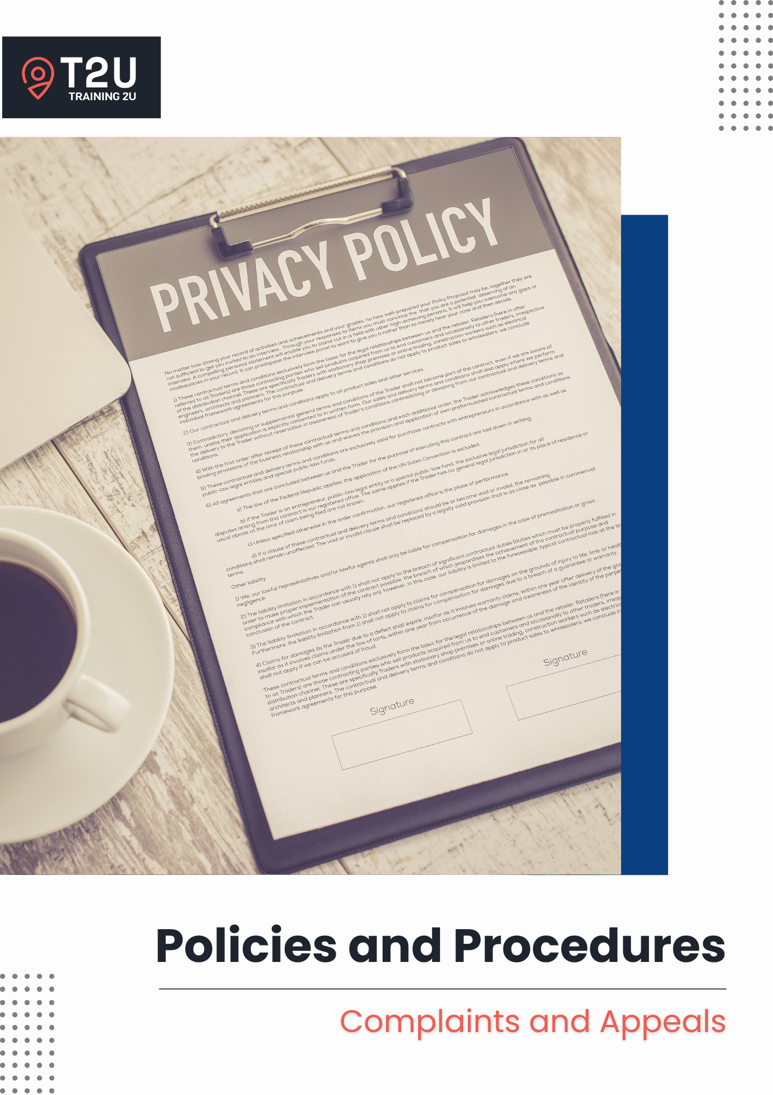

Table of Contents

Complaints and Appeals 3

Purpose 3

Scope 3

Software 3

Responsibilities 3

Definitions 4

General Principles 4

Compliance 5

Continuous Improvement 6

Related Documents 6

Complaints Handling Procedure 7

Appeals Handling Procedure 10

Complaints Handling Process Flow-Chart 13

# Complaints and Appeals

## **Purpose**

Training 2U is committed to maintaining a fair, transparent, and accessible complaints and appeals process. This policy ensures that all complaints and appeals are handled in accordance with the principles of natural justice, procedural fairness, ensuring timely resolution and supporting continuous improvement initiatives by using feedback to enhance our practices, operations and services.

## Scope

This policy applies to:

* All staff, learners, clients and any third-parties we work with; and
* All aspects of our operations.

## Software

* Ecosystem: Training 2U

## Responsibilities

**CEO**

* Ensures timely resolution of complaints and appeals.
* Oversees investigations and approve outcomes.
* Ensures compliance with the principles of natural justice and procedural fairness.

**RTO Manager**

* Conducts impartial investigations into complaints and appeals (unless the complaint involves the RTO Manager, in which case another staff member will be assigned).

**Administrative & Support Staff**

* Facilitates communication between all parties and staff involved in the investigation processes.
* Records and maintain complaints and appeals documentation.
* Provides administrative support for investigations and communication.

**All Staff**

* Cooperates fully with investigations, where required.

## Definitions

* A **complaint** is a dissatisfaction expressed regarding services, staff, other learners, or third-party providers with Training 2U It may involve matters concerning the quality of our courses, the efficiency of our systems and processes, the conduct of another learner, interactions with one of our staff members, or a third-party marketing our courses.

Staff members should do their best to address, acknowledge and resolve issues that arise as they occur. Where it is not possible, the individual should be encouraged to lodge a complaint. A complaint can be made in any form and does not need to be formally documented by the complainant in order for us to act on it. However, we should encourage the complainant to complete our *Complaint Form* to ensure the accuracy of the information. It can be made by any person, whether they are a learner, a staff member or even a passer-by. There is no time limitation on a person who is seeking to make a complaint.

* An **appeal** is a formal request to review a decision made by Training 2U Appeals may relate to assessment judgements or other decisions made by us or a third-party which adversely impacts the appellant. An appellant must complete the *Appeals Form*, which is available on our website, or it can be requested for by the Administrative & Support Staff and it is to be submitted either in hard copy, or electronically via e-mail to [info@t2u.com.au](mailto:info@t2u.com.au) An appeal must be made within **20 business days** from the date the decision is informed to the individual.

## General Principles

Training 2U commits to the following principles when handling complaints and appeals:

* Resolve all complaints and appeals within 60 calendar days. If additional time is required, the complainant or appellant must receive updates fortnightly on the progress.
* Handle all complaints and appeals at no cost to the complainant or appellant.
* Record and securely maintain all complaints and appeals documentation in the Complaints and Appeals Register.
* Strict confidentiality is upheld – only authorised personnel has access to the Complaints and Appeals Register and related documentation.
* Ensure no negative consequences or discrimination will result from lodging a complaint or appeal and the principles or natural justice and procedural fairness are observed:
  + The complainant or appellant is entitled to be heard with access to all relevant information with the right of reply;
  + Have their matter heard and reviewed by an unbiased decision-maker; and
  + The decision must be made based on evidence, logical reasoning and proper considerations.
* Provide support mechanisms, including allowing individuals to be accompanied by a support person during meetings and regular check-ins to assess their mental and emotional wellbeing.
* Cooperate with external agencies or statutory bodies investigating the handling of complaints and/or appeals.
* If a complaint concerns a staff member, they will not be involved in the investigation.
* Provide access to an independent reviewer if the complainant or appellant is dissatisfied with the internal process.
* Utilise complaints and appeals as opportunities for continuous improvement and take immediate corrective action to mitigate recurrence; and
* Ensure this policy is publicly available, and easily accessible by our prospective and current learners, clients, staff and third-parties – published in our Student Handbook and on our website.

## Compliance

This policy aligns with **Standards for RTOs 2025**:

* **Standard 2.7** – Effective feedback and complaints management addresses concerns and informs continuous improvement.
* **Standard 2.8** – Effective appeal processes are available where decision of the RTO or a third-party adversely impact a VET student.
* **Standard 4.1** – The RTO operates with integrity and is accountable for the delivery of quality services.
* **Standard 4.2** – Roles and responsibilities are clearly defined and understood.
* **Standard 4.3** – Risks to VET students, staff and the RTO are identified and managed.
* **Standard 4.4** – The RTO undertakes systematic monitoring and evaluation to support the delivery of quality services and continuous improvement.

Failure to comply with this policy can have serious consequences, including but not limited to:

* **For the RTO** – non-compliance can result in the loss of our accreditation, loss of reputation, and compensation claims by the complainants and/or appellants, and costs which may arise from disputes, legal proceedings or the hiring of independent parties for dispute resolution.
* **For learners and clients** – non-compliance can result in a poor and frustrating student experience with us, cause unnecessary frustrations which can lead to mental and emotional harm, and adversely affect the outcomes of their training program.

## Continuous Improvement

* Feedback from staff, learners, clients and industry stakeholders will be used to inform improvements to compliance processes and the effectiveness of our operations.
* An internal audit is to be conducted at least once per year to assess our compliance with this policy and the relevant legislative and regulatory requirements. The audit schedule is outlined in our *Continuous Improvement Schedule* and areas for improvements are documented in our *Continuous Improvement Register*.
* Internal audit review questions for self-assurance purposes should include:
  + How do you ensure students and others are made aware of the processes for complaints and appeals, including independent reviews?
  + How do you ensure your complaints and appeals management systems are procedurally fair, timely and effective?
  + How are the outcomes of complaints and appeals used to continuously improve your services?

## Related Documents

* Appeals – Acknowledgement of Appeal letter template
* Appeals – Successful letter template
* Appeals – Unsuccessful letter template
* Appeals Form
* Complaint Form
* Complaints – Acknowledgement of Complaint letter template
* Complaints – Unwarranted letter template
* Complaints – Warranted letter template
* Complaints and Appeals Register
* Continuous Improvement Register
* Continuous Improvement Schedule
* Student Handbook

## Complaints Handling Procedure

1. **Complaint submission**
2. When a complaint is received, the information is to be recorded in our *Complaints and Appeals Register*.
3. If a *Complaint Form* is submitted, scan and save the form on the *Complaints and Appeals Register*, and securely destroy the physical document. If a complaint is verbally submitted, encourage the complainant to complete a *Complaint Form*. This is to ensure we capture the information accurately and completely. If the complainant is unwilling to complete a form, take down as much information as possible verbally (using the *Complaint Form*) and enter the data into our *Complaints and Appeals Register*.
4. The *Complaints and Appeals Register* must be updated regularly throughout the complaints handling process.
5. A note is to be left on the student’s or staff member’s file (if applicable) regarding the complaint.
6. **Acknowledgement of complaint**
7. An *Acknowledgement of Complaint* letter is to be sent within **2 business days** of receiving the complaint**.** In this letter, they are to be informed we have received their complaint, our complaints handling process, and the associated timeframe in which we will endeavour to finalise the matter.
8. Where the complainant is under the age of 18, their parent or legal guardian must also be sent copies of all correspondences regarding the complaint.
9. **CEO notification**
10. The CEO is then to be notified of the complaint via e-mail and the completed *Complaint Form* forwarded to the CEO.
11. Where the complaint is about the CEO, an independent and external consultant with experience in handling RTO complaints is to be appointed to oversee and take charge of the investigation of the complaint.
12. **Investigate the complaint**
13. The investigation must:
    * Commence within **5 business days** of the lodgement of the complaint;
    * Seek to identify the potential cause(s) of the complaint – meet with the complainant, consult with other parties such as witnesses to the event, as well as reviewing the evidences provided and any other relevant materials to assist the CEO (or the independent consultant) in making a determination;
    * Consult with the complainant on what outcome or resolution they are seeking; and
    * Undertake research and speak to a lawyer or a Compliance Consultant on what corrective actions and potential disciplinary measures is fair and suitable.
14. Throughout the complaints handling process, the Administrative & Support Staff must check-in with thecomplainant at least once a fortnight to assess their mental and emotional well-being.
15. **Prepare a response to the complainant**
16. As a benchmark, we will endeavour to resolve all complaints as soon as possible, but no later than 60 calendar days from when the assessment of the complaint commenced. If a complaint is unable to be finalised within 60 calendar days, the complainant should be notified on a fortnightly interval of the progress of the investigation and why the additional time is required.
17. The response to the complainant must include:
    * Our obligations as an RTO and the process followed to arrive at our decision,
    * Information that demonstrates that the matter was thoroughly reviewed,
    * What outcomes have been identified as a result of the complaint, and
    * What corrective actions and disciplinary measures (if applicable) will be taken and when.
18. Must be prepared within **3 business days** of the end of the investigation.
19. **Communicate the outcome to the complainant**
20. The outcome of the investigation is to be communicated to the complainant in an in-person meeting, and a written response provided to the complainant in the meeting. Under no circumstances is the response to be provided via a third-party.
21. The complainant is to be advised that they can bring a support person to the meeting. This should be done as soon as possible, and no later than **5 business days** from when the investigation is completed.
22. Where the complainant is under the age of 18, their parent or legal guardian must also be present.
23. Where the complainant is unable to meet in person, organise a virtual session.
24. Should the complainant be dissatisfied with the outcome of their complaint, advise the complainant of their ability to access an independent review process.
25. The outcome must also be recorded in the *Complaints and Appeals Register*.
26. **Independent review**
27. Where the complainant is dissatisfied with the outcome or the handling of the complaint, the CEO is to arrange for the complaint to be considered by an appropriate independent third-party – **The Dispute Settlement Centre of Victoria** or **Mediate Today** or one locally.
28. Any recommendations made by the independent third-party will be accepted as final, advised to the complainant and implemented by Training 2U within **10 business days** (unless circumstances does not permit) without prejudice.
29. Where the complainant is still dissatisfied with the outcome, they may refer the matter to the National Training Complaints Service – 13 38 73.
30. **Continuous improvement**
31. Record improvement opportunities from the complaint in the *Continuous Improvement Register* for discussion at the next management meeting and we are to enact our Continuous Improvement policy and procedure.
32. Decisions or outcomes favouring the complainant is to be implemented immediately.

## Appeals Handling Procedure

1. **Appeal submission**
2. It is important that the form is checked for completeness, and that the appeal is made no later than **20 business days** from when the decision was advised to the individual.
3. If an *Appeal Form* is submitted, scan and save the form on the *Complaints and Appeals register*, and securely destroy the physical document. If an appeal is verbally submitted, encourage the appellant to complete an *Appeal Form*. This is to ensure we capture the information accurately and completely. If the appellant is unwilling to complete a form, take down as much information as possible verbally (using the *Appeals Form*) and enter the data into our *Complaints and Appeals Register*.
4. The *Complaints and Appeals Register* must be updated regularly throughout the appeals handling process.
5. A note is to be left on the student’s or staff member’s file (if applicable) regarding the complaint.
6. **Acknowledgement of appeal**
7. An *Acknowledgement of Appeals* letter is to be sent within **2 business days** of receiving the complaint**.** In this letter, they are to be informed we have received their appeal, our appeals handling process, and the associated timeframe in which we will endeavour to finalise the matter.
8. Where the complainant is under the age of 18, their parent or legal guardian must also be sent copies of all correspondences regarding the appeal.
9. **CEO notification**
10. The CEO is then to be notified of the appeal via e-mail and the completed *Appeals Form* forwarded to the CEO.
11. Where the complaint is about a decision made by the CEO, an independent and external consultant with experience in handling RTO appeals is to be appointed to oversee and take charge of the investigation of the appeal.
12. **Review the appeal request**
13. The investigation into the request for appeal must:
    * Commence within **5 business days** of the lodgement of the appeal;
    * Involve consulting with the Trainer & Assessor or personnel that made the decision being appealed by the appellant; and
    * Include reviewing the materials, notes and evidences such as the completed assessment and marketing tools to assist in arriving at a determination.
14. Where the appeal is in relation to an assessment decision, a re-assessment may be recommended. Learners participating in a re-assessment should be provided with detailed counselling about the perceived gaps in their skills and knowledge, along with additional training to support the improvement and ability to demonstrate competence. Re-assessments should be scheduled to occur as soon as possible following the outcome of an appeal. The re-assessment should be undertaken by a different Assessor than used during the initial assessment and following the re-assessment, the learner must be provided with detailed feedback about their performance and the outcome.
15. Throughout the appeals handling process, the Administrative & Support Staff must check-in with thecomplainant at least once a fortnight to assess their mental and emotional well-being.
16. **Prepare a response to the appellant**
17. As a benchmark, we will endeavour to resolve all appeals as soon as possible, but no later than 60 calendar days from when the assessment of the complaint commenced. If a complaint is unable to be finalised within 60 calendar days, the appellant should be notified on a fortnightly interval of the progress of the investigation and why the additional time is required.
18. The response to the complainant must include:
    * Our obligations as an RTO and the process followed to arrive at our decision,
    * Information that demonstrates that the matter was thoroughly reviewed,
    * What outcomes have been identified as a result of the appeal, and
    * What corrective actions will be taken and when (if applicable).
19. Must be prepared within **3 business days** of the end of the investigation.
20. **Communicate the outcome to the appellant**
21. The outcome of the review is to be communicated to the appellant in an in-person meeting, and a written response provided to the appellant in the meeting. Under no circumstances is the response to be provided via a third-party.
22. The appellant is to be advised that they can bring a support person to the meeting. This should be done as soon as possible, and no later than **5 business days** from when the investigation is completed.
23. Where the appellant is under the age of 18, their parent or legal guardian must also be present.
24. Where the appellant is unable to meet in person, organise a virtual session.
25. Should the appellant be dissatisfied with the outcome of their appeal, advise the appellant of their ability to access an independent review process.
26. The outcome must also be recorded in the *Complaints and Appeals Register*.
27. **Independent review**
28. Where the appellant is dissatisfied with the outcome or the handling of the appeal, the CEO is to arrange for the appeal to be considered by an appropriate independent third-party – **The Dispute Settlement Centre of Victoria** or **Mediate Today** or one locally.
29. Any recommendations made by the independent third-party will be accepted as final, advised to the appellant and implemented by Training 2U within **10 business days** (unless circumstances does not permit) without prejudice.
30. Where the appellant is still dissatisfied with the outcome, they may refer the matter to the National Training Complaints Service – 13 38 73.
31. **Continuous improvement**
32. Record improvement opportunities from the appeal in the *Continuous Improvement Register* for discussion at the next management meeting and we are to enact our Continuous Improvement policy and procedure.
33. Decisions or outcomes favouring the appellant is to be implemented immediately.

## Complaints Handling Process Flow-Chart

Start

Complaint is received

Complaint is forwarded to CEO

Has Complaints Form been submitted?

Enter complaint into Complaints and Appeals Register and student or employee file (if applicable), and send out acknowledgement letter within 2 business days

Person receiving complaint completes Complaint Form

Complaint reviewed within 5 business days of receipt of complaint

Complainant is provided with options for escalating complaint

Is investigation / consultation required?

Complaint response provided to complainant within 5 business days

Is complainant satisfied?

Implement complaint outcomes and raise opportunity for improvement action

Investigate complaint within 60-days

Outcome of investigation reviewed

Update Complaints and Appeals Register and the Continuous Improvement Register

Y

N

N

Y

N

Y

**Version Control**

|  |  |
| --- | --- |
| **Title** | **Policies and Procedures – Privacy Protection** |

|  |  |
| --- | --- |
| Date of Approval | 1 July 2025 |
| Next Review Date | 1 July 2026 |
| Responsible Authority | CEO – Tooba Khan |
| Version Number | 2.0 |
| File Location | organisation’s server |

**Details of Changes**

|  |  |  |
| --- | --- | --- |
| **Version No.** | **Date** | **Amendments** |
| Version 1.0 | 01/02/2022 | - |
| Version 1.1 | 15/01/2024 | Fixed minor grammatic errors |
| Version 2.0 | 01/07/2025 | Updated in line 2025 Standards for RTOs |

*Add more rows as required.*