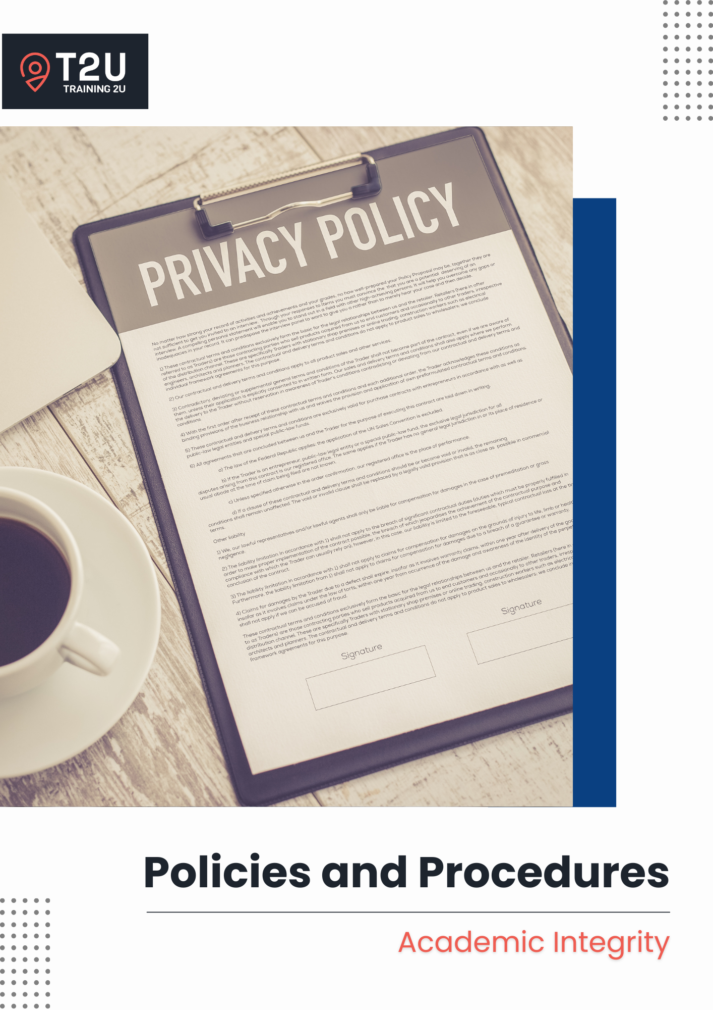

Table of Contents

Academic Integrity 3

Purpose 3

Scope 3

Software 3

Responsibilities 3

General Principles 4

Referencing 5

Compliance 6

Continuous Improvement 7

Related Documents 7

Academic Integrity Procedure 7

Academic Integrity Process Flow-Chart 10

# Academic Integrity

## Purpose

Academic integrity is the commitment to and demonstration of honest and moral behaviour in an academic setting. This is most relevant at a vocational level as it relates to unethical behaviours present in completing the assessments, the use of AI and providing credit to other people when using their ideas where it requires the acknowledgement of other individual’s contributions. Failure to provide such acknowledgement is considered plagiarism.

## Scope

This policy applies to:

* All Trainers & Assessors and learners; and
* All of our training and assessment services.

## Software

* Ecosystem: Training 2U

## Responsibilities

**CEO**

* Ensures compliance with legislation, regulations and Standards for RTOs.

**RTO Manager**

* Conducts induction and refresher training for staff regarding relevant legislative requirements and implement updates (where applicable).

**Trainers & Assessors**

* Informs learners about expectations regarding academic integrity during induction and throughout the delivery of our training and assessment services.
* Educates learners on proper referencing techniques and provide examples.
* Addresses breaches of academic integrity and guide learners toward compliance.

**Definitions**

* **Plagiarism** is the act of using someone else’s work or ideas and passing them off as one’s own work. It is a type of intellectual theft and can take on many forms:
  + **Collusion** – when learners submit the work of someone else and call it one’s own, with full knowledge and consent of the other person who has supplied the work, in order to give a false representation of one’s effort or performance on the assessment item. The person supplying the work can also be deemed to have participated in collusion. Unintentional collusion can arise from study groups and from group-based assessment where students are unsure about the boundaries between what is considered acceptable group work and collusion.
  + **Ghost writing** – when an assessment is purposely written by another person and represented by the student as his or her own work.
  + **Incorrect referencing** – when material is copied word for word and acknowledged as paraphrased but should have been in quotation marks, or material paraphrased without appropriate acknowledgement of its source.
  + **Purloining** – when material is copied from another learner’s.
  + **Re-submission of material** – when the material has been submitted by another student.
* **Referencing** enables learners to acknowledge the contribution of and provide credit to others in their work. This shows that the learners respect the intellectual property rights of others.

## General Principles

Training 2U is committed in minimising instances of student plagiarism, cheating and collusion by:

* Providing a learning environment that fosters the qualities of independent learning and academic integrity.
* Developing our learner’s ability to apply critical reasoning and knowledge to assessment activities through independent thought and to make decisions that reflect the learner’s considerations of the task or workplace requirement.
* Advising all learners of the importance of academic integrity and the impact plagiarism, cheating and colluding has on not just the learners, but their classmates, the RTO and the wider vocational education reputation.
* Educating learners that their assessment submissions must consist of original effort. It is insufficient to simply copy work from other sources and submit it, even if those sources are appropriately acknowledged.
* Treating all forms of plagiarism, cheating and collusion seriously and apply appropriate consequences where learners are found to be plagiarising, cheating or colluding.
* Ensuring that learners understand how to use Artificial Intelligence (AI) tools such as ChatGPT responsibly and the extent of the scope, including in which instances they will not be allowed to do so.

## Referencing

Failure to reference appropriately is considered unethical academic behaviour and will result in a learner’s work not being accepted. Careless or inadequate referencing is considered as poor practice. Where careless referencing is identified, the learner will be required to correct the error and re-submit their assessment.

Printed books are not the only sources that require acknowledgement. References will need to be made when using words or ideas from:

* Books and journal articles
* Organisation reports
* Pamphlets or brochures
* Films, documentaries, television programs or advertisements
* Websites, letters, e-mails, online discussion forums

Where the knowledge and material has become part of the public domain, and which can be drawn on without specific acknowledgement such as common facts of history, common sense information, accepted folklore and aphorisms do not require any referencing. For example, Singapore became an independent nation in 1965.

At Training 2U, we encourage our learners to apply the Harvard Referencing System in-text citation and reference list. This approach requires three pieces of information about a source:

* The name of the author(s)
* The year of publication
* The page number

Example:

|  |  |
| --- | --- |
| **In-text Citation** | **Reference List** |
| According to Salzmann, Stanlaw and Adachi (2012), unwritten languages are primitive.  OR  Salzmann, Stanlaw and Adachi (2012, p.4) further explore the established misconception that unwritten languages are primitive.  OR  A common misconception is that unwritten languages are primitive (Salzmann, Stanlaw & Adachi 2012, p. 4). | Salzmann, Z, Stanlaw, J & Adachi, N 2012, *Language, Culture and Society: An Introduction to Linguistic Anthropology*, Westview Press, Boulder, CO. |

Here are some quick guides created by other institutions for reference:

* [Monash University’s Harvard Referencing Guide](https://guides.lib.monash.edu/ld.php?content_id=8481587)
* [The University of Sydney’s Your guide to Harvard style referencing](https://libguides.library.usyd.edu.au/ld.php?content_id=22570384)
* [Deakin University’s Harvard – Guide to referencing](http://www.deakin.edu.au/__data/assets/pdf_file/0004/392305/Deakin-guide-to-Harvard.pdf)

**Use of Artificial Intelligence (AI)**

The use of AI tools such as ChatGPT and other generative AI platforms has become increasingly common in academic and vocational settings. While AI can be a useful tool for research, idea generation, and improving writing clarity, it must be used responsibly.

At Training 2U, learners and staff are expected to adhere to the following AI usage guidelines:

* AI-generated content must be properly acknowledged when used in any submitted work.
* AI tools should not be used to generate any assessment responses or replace a learner’s independent effort. We use tools such as [insert software program name] to detect any AI written content.
* Trainers & Assessors will provide clear guidance on when AI tools are permissible and when they are not.
* Unauthorised or excessive reliance on AI tools, including using AI to complete assessments is considered a breach of academic integrity and will result in a learner’s work not being accepted. Careless or inadequate referencing is considered as poor practice. Where careless referencing is identified, the learner will be required to correct the error and re-submit their assessment.
* Failure to comply with these guidelines may result in appropriate disciplinary action.

## Compliance

This policy aligns with:

* **Standards for RTOs 2025**:
  + **Standard 1.4** – The assessment system ensures assessment is conducted in a fair and appropriate way and enables accurate judgements of VET student competency.
  + **Standard 4.2** – Roles and responsibilities are clearly defined and understood.
  + **Standard 4.3** – Risks to VET students, staff and the RTO are identified and managed.
  + **Standard 4.4** – The RTO undertakes systematic monitoring and evaluation to support the delivery of quality services and continuous improvement.

Failure to comply with this policy can have serious consequences, including but not limited to:

* **For the RTO** – breaches of legislation or regulatory requirements may result in financial penalties, loss of registration, reputation damage, or regulatory enforcement actions.
* **For Staff Members** – staff found to have knowingly or negligently failed to comply with this policy and any associated legislative or regulatory requirements may face disciplinary actions, up to and including termination of employment.
* **For Learners and Clients** – non-compliance could lead to disruptions in training and assessment services, formal warnings issued, or even suspensions or expulsion.

## Continuous Improvement

* Feedback from staff, learners, clients and industry stakeholders will be used to inform improvements to compliance processes and the effectiveness of our operations.
* An internal audit is to be conducted at least once per year to assess our compliance with this policy and the relevant legislative and regulatory requirements. The audit schedule is outlined in our *Continuous Improvement Schedule* and areas for improvements are documented in our *Continuous Improvement Register*.
* Internal audit review questions for self-assurance purposes should include:
  + Is our policy clearly communicated to students in a manner that is easily understood?
  + How many breaches of this policy were uncovered? What were the trends?
  + Are assessments designed in a way that encourages original thought and reduces opportunities for copying or AI misuse?

## Related Documents

* Continuous Improvement Register
* Continuous Improvement Schedule
* Student Handbook

## Academic Integrity Procedure

1. **Educate learners**
2. To submit only work that:
   * + - Is their own or that properly acknowledges the ideas or works of others; and
       - Avoids lending original work to others for any reason.
3. Understands the Academic Integrity policy and seek out clarification if in doubt.
4. Understands how to correctly reference and the consequences of inappropriate referencing.
5. Understands the different between collusion and group work, where appropriate.
6. Understands the consequences of breaching the Academic Integrity policy.
7. **Suspicions of plagiarising, cheating or colluding**
8. Where work submitted is suspected of having breached the Academic Integrity policy such as where they have colluded with another learner or where they have copied off another learner’s work, the Trainer & Assessor will report the incident to the CEO.
9. Where our plagiarism checker and AI-detection software, [insert name of software] has detected any plagiarism or that AI has written the content in the assessment submission, the Trainer & Assessor will report the incident to the CEO.
10. **Investigation**
11. The CEO, in consultation with the Trainer & Assessor will investigate and determine if the plagiarism, cheating or colluding resulted from poor understanding of our Academic Integrity policy, or if it was intentional.
12. It is important to investigate how and why plagiarism, cheating or collusion occurred. Many students who plagiarise do so unintentionally, often because they do not have the academic skills to avoid over-reliance on the work of others or because they do not know what constitutes plagiarism. However, students who cheat or collude are generally aware of their intended actions.
13. **Interview the learner**
14. As part of the investigation, an interview is to be organised with the learner to address the detection of the plagiarism, cheating or collusion (noting that the more extensive the plagiarism, cheating or collusion the more likely it was deliberate).
15. **Determined that breach arose from lack of understanding**
16. The learner will be requested to revise the work and re-submit for the assessment.
17. The learner will be issued with a formal warning in writing detailing the seriousness of the incident and the consequences if the learner is found to plagiarise again.
18. The Trainer & Assessor is to sit down with the learner and help them understand our Academic Integrity policy better by explaining it to them clearly and clarifying any doubts they may have.
19. **Determined that breach was intentional**
20. If after consideration and investigation, the learner is found to have plagiarised, cheated or colluded intentionally, their work is not to be accepted.
21. The learner will be issued with an alternative assessment to complete.
22. The learner will be issued with a formal warning in writing detailing the seriousness of the incident and the consequences if the learner persists with this behaviour.
23. **Serial plagiarism, cheating or colluding offenders**
24. Learners who persist in plagiarising, cheating or colluding, after being formally warned three times are to be removed from the training program.
25. **Record management**
26. All notes are to be recorded promptly in the student’s file in detail with all evidences such as the completed assessment tool and meeting agenda from interviewing the learner, are to be scanned and saved.
27. Any hardcopies are then to be destroyed securely.
28. **Continuous improvement**
29. We are to review the Student Handbook and the assessment tools to determine if adequate information and instructions had been provided to the learners.
30. Apply our Continuous Improvement processes to address this.

## Academic Integrity Process Flow-Chart

Suspected plagiarism, cheating or collusion reported to the CEO

CEO investigates and interviews learner

Save all records to the student’s file

N

Y

Candidate formally warned and requested to re-submit assessment

Plagiarism intentional?

Candidate issued with a written warning and alternative assessment

Learner removed from training program

Previous warning issued?

N

Y

**Version Control**

|  |  |
| --- | --- |
| **Title** | **Policies and Procedures – Privacy Protection** |

|  |  |
| --- | --- |
| Date of Approval | 1 July 2025 |
| Next Review Date | 1 July 2026 |
| Responsible Authority | CEO – Tooba Khan |
| Version Number | 2.0 |
| File Location | organisation’s server |

**Details of Changes**

|  |  |  |
| --- | --- | --- |
| **Version No.** | **Date** | **Amendments** |
| Version 1.0 | 01/02/2022 | - |
| Version 1.1 | 15/01/2024 | Fixed minor grammatic errors |
| Version 2.0 | 01/07/2025 | Updated in line 2025 Standards for RTOs |

*Add more rows as required.*